Axis The Information Technology Professionals
AxisITP Price Comparison Script
User Guide
Step 1:
Creating categories and sub categories.
Sign in through your admin panel:
Add Parent Category:
Click on Categories menu and then Select Dropdown (Root Level) and then enter category name in Text Box, if you want to assign any image with category please browse image and press submit button.
You category will be added. (You can add as much parents categories as you want).
Adding Subcategory:
Click on Categories menu and then Select Dropdown (Category Name) and then enter category name in Text Box, if you want to assign any image with category please browse image and press submit button.
Your child category will be added. (You can add as much child categories as you want).
Tips: How Parents Categories and Child Categories look like?
For Example:
- Parent Category 1
- Parent Category 2
- Parent Category 3
  - Child Category 1
  - Child Category2
  - Child Category3
    - Sub Child Category1
    - Sub Child Category2
    - Sub Child Category3
- Parent Category4
- Parent Category5

Step 2:
Adding Merchant:
Sign up through your website Merchant Registration link and create account(s) for yourself and you can use this merchant account(s) for adding products by yourself.
Step 3:
Adding Products:
Sign in through your admin panel:
There are currently six type of feature available for adding products!
Do you want to add products manually?
If yes, Please click on Add Products link and fill the form.
Do you want to add products using CSV?
If Yes, Please click on Import CSV link and Select Merchants through Dropdown then Select Category and then browse your csv file and press a button Upload.
You will see a page which will show you CSV column and Map with Database Column, choose each dropdown box and map them with csv columns and press Import to Database button.
Example:
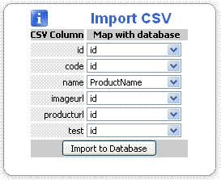
For Example: CSV Column (Name) will be mapped with Database Column (ProductName)
Your product will be added to Mapping Area.
Do you want to add product using XML?
There are two type of function for xml,
1)- Auto Crawl
2)- Manual (Upload Function).
- Auto Crawl: If your xml data feed is available on remote server then use Auto Crawl Function.
Click on Auto Crawl Products link and then select Category and Merchant through dropdowns.
Then Enter XML file link in text box and fill each textbox with xml entities name. Press button Submit, your products will be added into Mapping Area:
- Manual XML: If your xml data feed is available on your local computer then use Manual XML Click on Import Products link and then select Category and Merchant through dropdowns.
Then browse XML file and fill each textbox with xml entities name. Press button Submit, your products will be added into Mapping Area:
Do you want to add products through Amazon Manual Job?
If Yes, Then Click on Amazon - (Manually) link and then click on any Category and click on any page number
For Example:
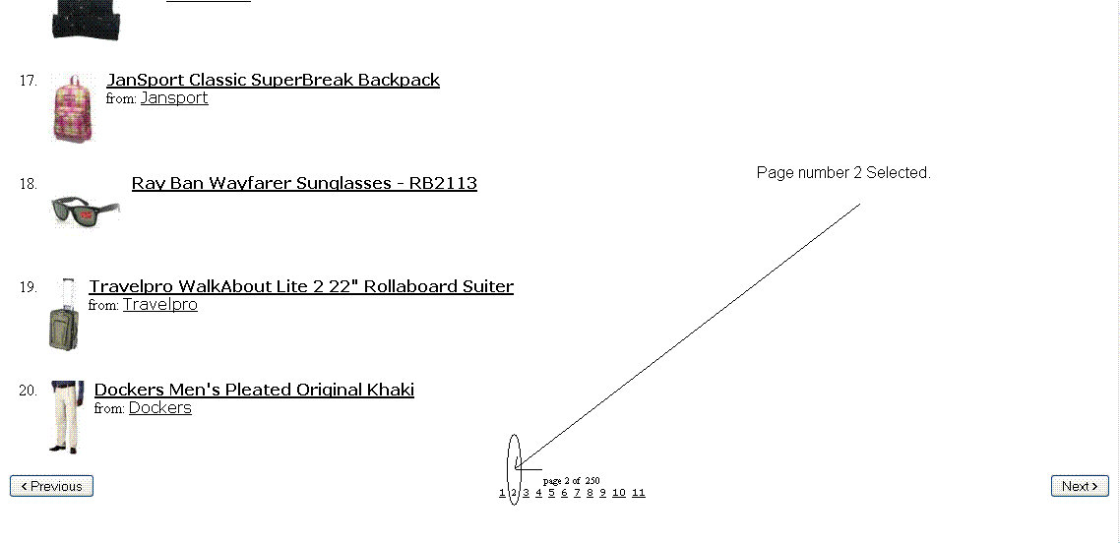
Then Select your category where you want to add these products:
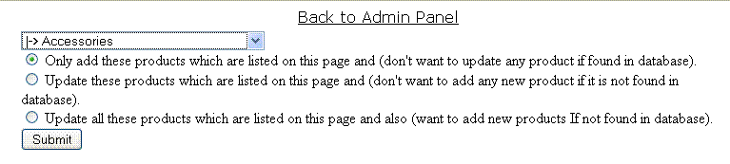
Choose a radio button and then press button Submit
Your products will be added into your website and will be shown on pages.
Do you want to add products through Amazon Corn Job?
If Yes, Then Click on Amazon - (Corn Job) link. Please see the Example of Amazon Manual Job above it also work like the above example works.
This feature adds products automatically if the corn Application is already added in your website control panel (Cpanel).
For more help about the Amazon Corn Job and Amazon Manual Job, please view or download our video tutorial at:
http://www.axisitp.com/products.php
Step 4:
Product Mapping:
Note: Product will be automatically displayed into product map area, if you have imported products through CSV function, Import XML and Auto Crawl XML.
The products from Amazon Corn Job and Amazon Manual Job will not be listed under Mapping Area.
You can Map each product to best potential matching product.
For more help about the Mapping Area, please view or download our video tutorial at:
http://www.axisitp.com/products.php
If you have any question please read FAQs: http://www.axisitp.com/best-price-comparison-script-faq.php
If you didn’t find your question please contact with us:
http://www.axisitp.com/contactus.php

